

The Brooklyn Hospital Center Financial Assistance Policy Plain Language Summary

Here at The Brooklyn Hospital Center (TBHC) we are committed to providing you with the best care possible and we are dedicated to increasing access to high-quality clinical care in the communities we serve. Receiving a hospital bill we understand is stressful this is why we have created a financial assistance policy at our hospitals and clinics that will alleviate some of this burden. You may qualify for help if you are unable to pay all or part of your bills for emergency or other medically necessary care.

# The Brooklyn Hospital Center Financial Assistance Policy Summary

For more details the full policy is available at WWW.XXXXXXXXXXXXXXX

# Eligible services

You may be eligible for financial assistance for emergency medical care and other medically necessary

services provided and billed by TBHC. Physician services rendered by providers employed by the hospital are also covered by this policy. A sliding scale fee discount is available for medically necessary services provided to uninsured patients in our hospital based clinics.

You may be eligible if you have no health insurance (uninsured) or if you have health insurance with high out-of-pocket costs that you are not able to pay (underinsured).

# How to apply for Financial Assistance

Submit a complete financial assistance application with all required documentation via mail, or by working with one of our Financial Counselors in person or via phone. You can get an application in any of the following ways:

* Online via the hospital’s website at: https://www.tbh.org/visitor-information/billing/financial-assistance
* At any of the main hospital’s registration desks and any of the hospital clinics
* By contacting the Financial Counselors Unit at 718-250-8080
* Mailing address:

The Brooklyn Hospital Center

Attn: Financial Counselors Unit 2nd Floor

121 DeKalb Avenue Brooklyn NY 11201

If you are a hospital patient, we encourage you to apply for financial assistance as soon as possible and within 90 days from your service date. Note, however, that you can submit a financial-assistance application at any time after you are treated at the hospital.

Hospital clinic patients are encouraged to submit your application before your first appointment, or to bring the materials necessary to submit an application on your first appointment.

If an incomplete application is received we will notify you and give you an opportunity to provide any missing information or documentation.

# Determination of eligibility

Financial assistance eligibility is based on family income and on other information you provide. If after reviewing your application it is determined that your family income is at 400% of the Federal Poverty Guidelines (FPG) you will be eligible for a discount on your bill for eligible services.

Below are 2025 Federal Poverty Guidelines and Discounts

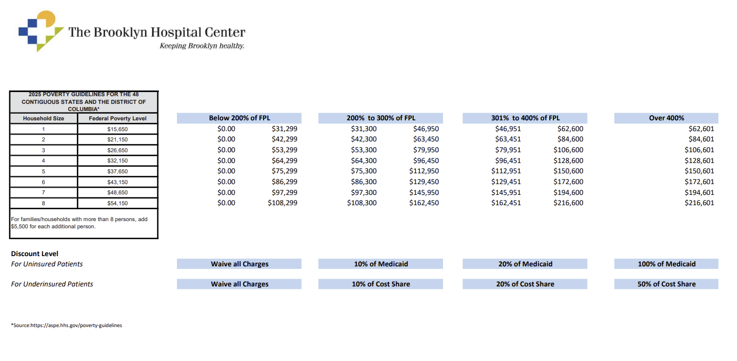

If your family income is less than or equal to 200% of the FPG, you may qualify for free hospital or hospital clinic care. If your family income is between 201% and 400% of the FPG, you may qualify for partial financial assistance.

**For non-English speakers**

You can find translations of this document at: [www.xxxxxxxxxxxxxxxxxxxxxxxxxxxxx](http://www.xxxxxxxxxxxxxxxxxxxxxxxxxxxxx)